## Indian Institute of Information Technology Surat



# Lab Report on

# Web Engineering (CS 603) Practical

**Submitted by**

### [RAHUL KUMAR SINGH] (UI21CS44)

**Course Faculty**

### Dr. Reema Patel

## Department of Computer Science and Engineering

## Indian Institute of Information Technology Surat

## Gujarat-394190, India

**Jan-2024**

## Lab No: 1

**Aim: Basic HTML,CSS.**

**Description:** Perform all the 5 Tasks:

1. Create a static webpage using table tags of HTML.

2. Create a static web page which defines all text formatting tags of HTML in tabular format.

3. Create employee login and registration webpage using HTML form objects.

4. Create a web page for your curriculum vitae using the following design

5. Design a website for the Tourism Sites of a given City.

## Source Code:

**Task 1:**

**<< Provided as an attachment >>**

**Task 2:**

**<< Provided as an attachment >>**

**Task 3:**

**<< Provided as an attachment >>**

**Task 4:**

**<< Provided as an attachment >>**

**Task 5:**

**<< Provided as an attachment >>**

## Output:

**Task 1:**

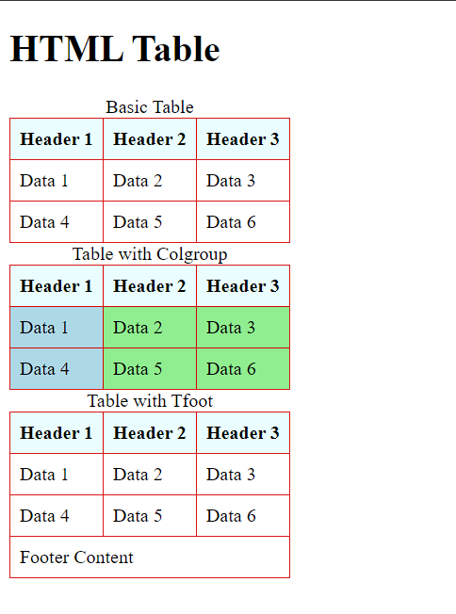

**Task 2:**

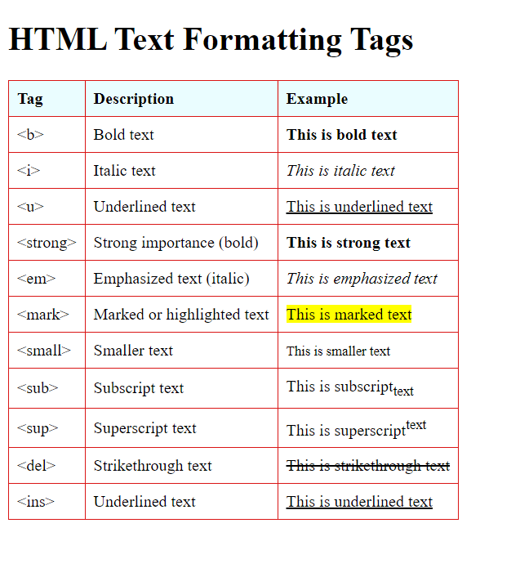

**Task 3:**

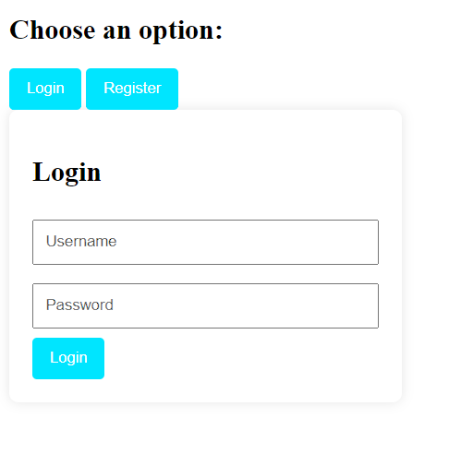

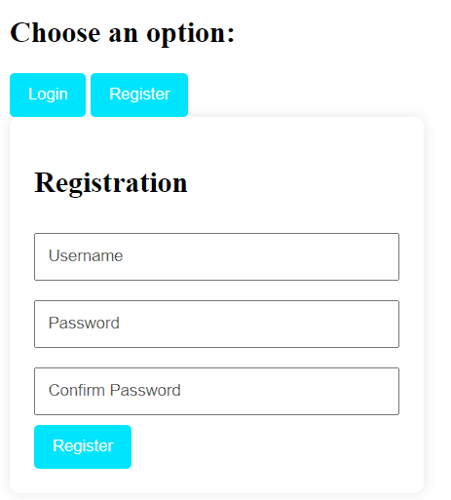

**Task 4:**

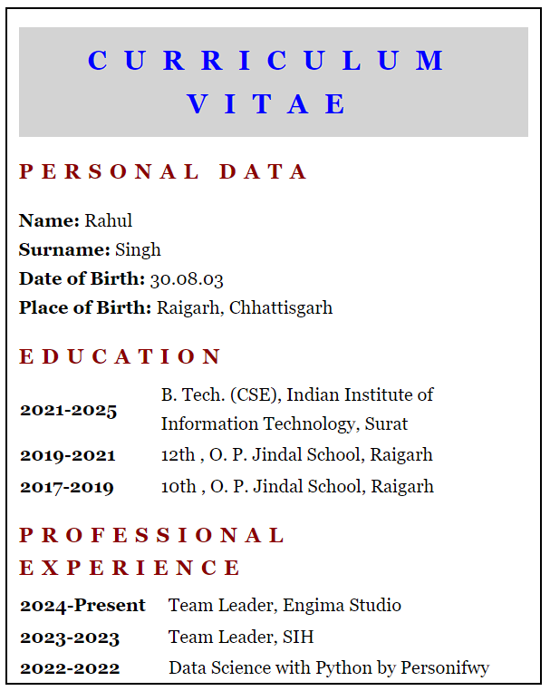

**Task 5:**

***Home Page***

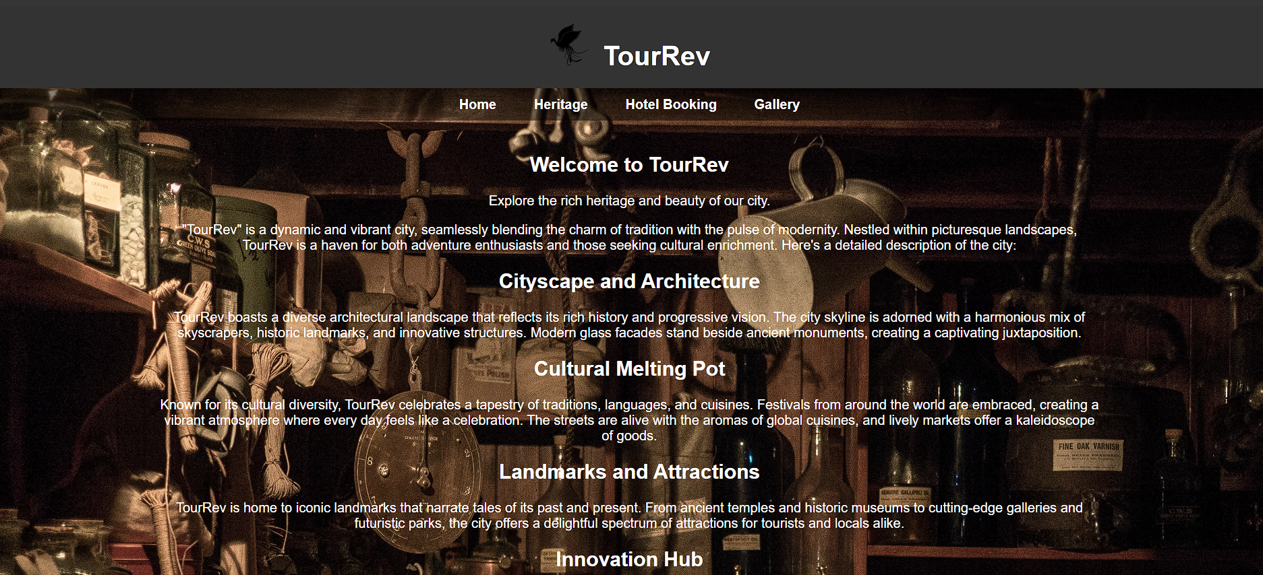

***Heritage Page***

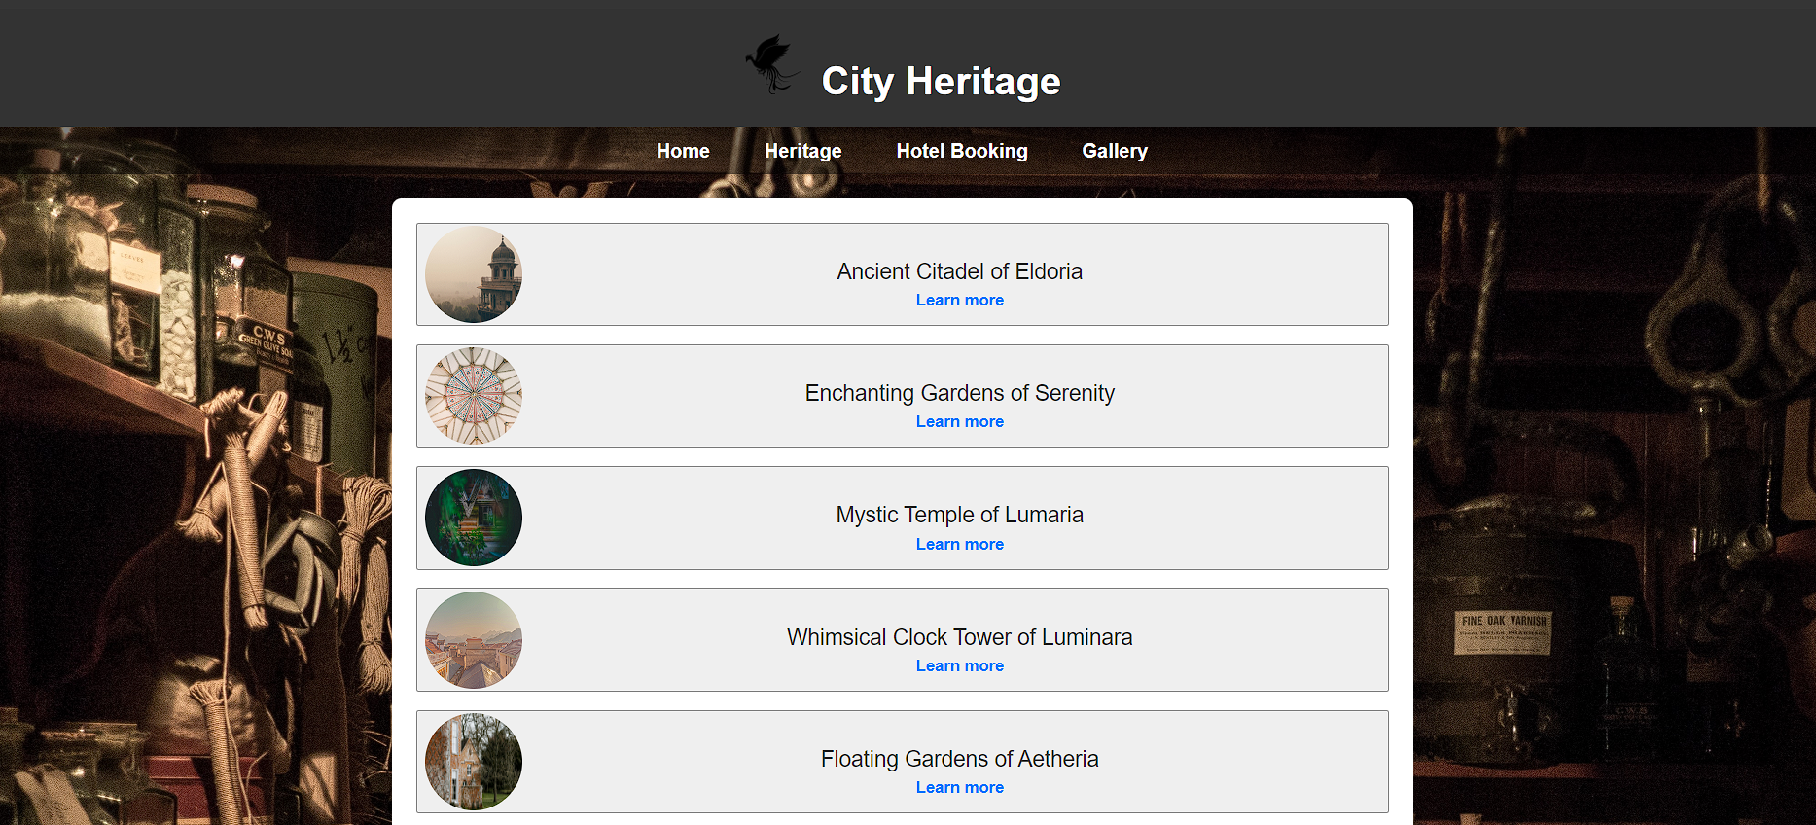

***Hotel Booking Page***

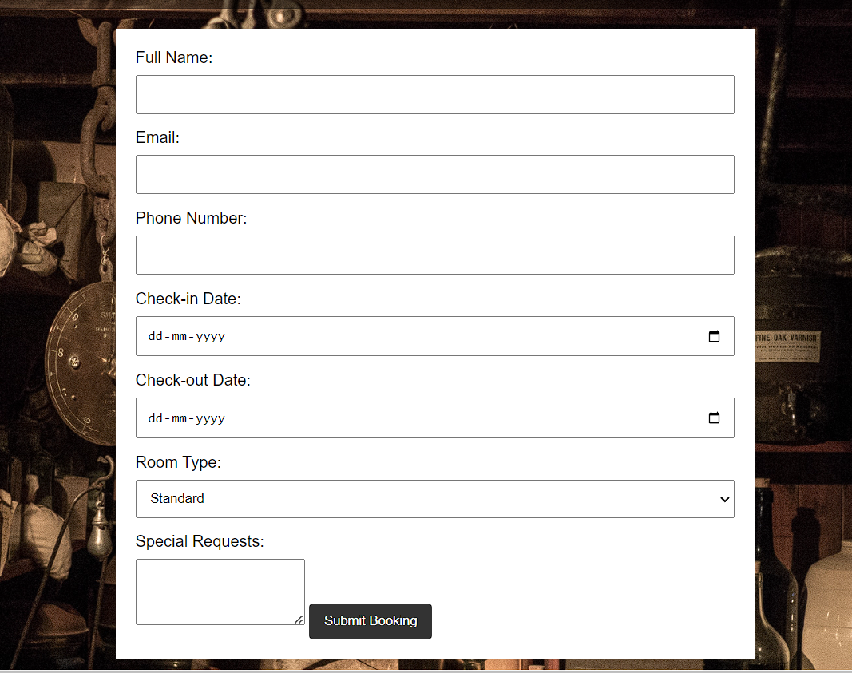

***Gallery Page***

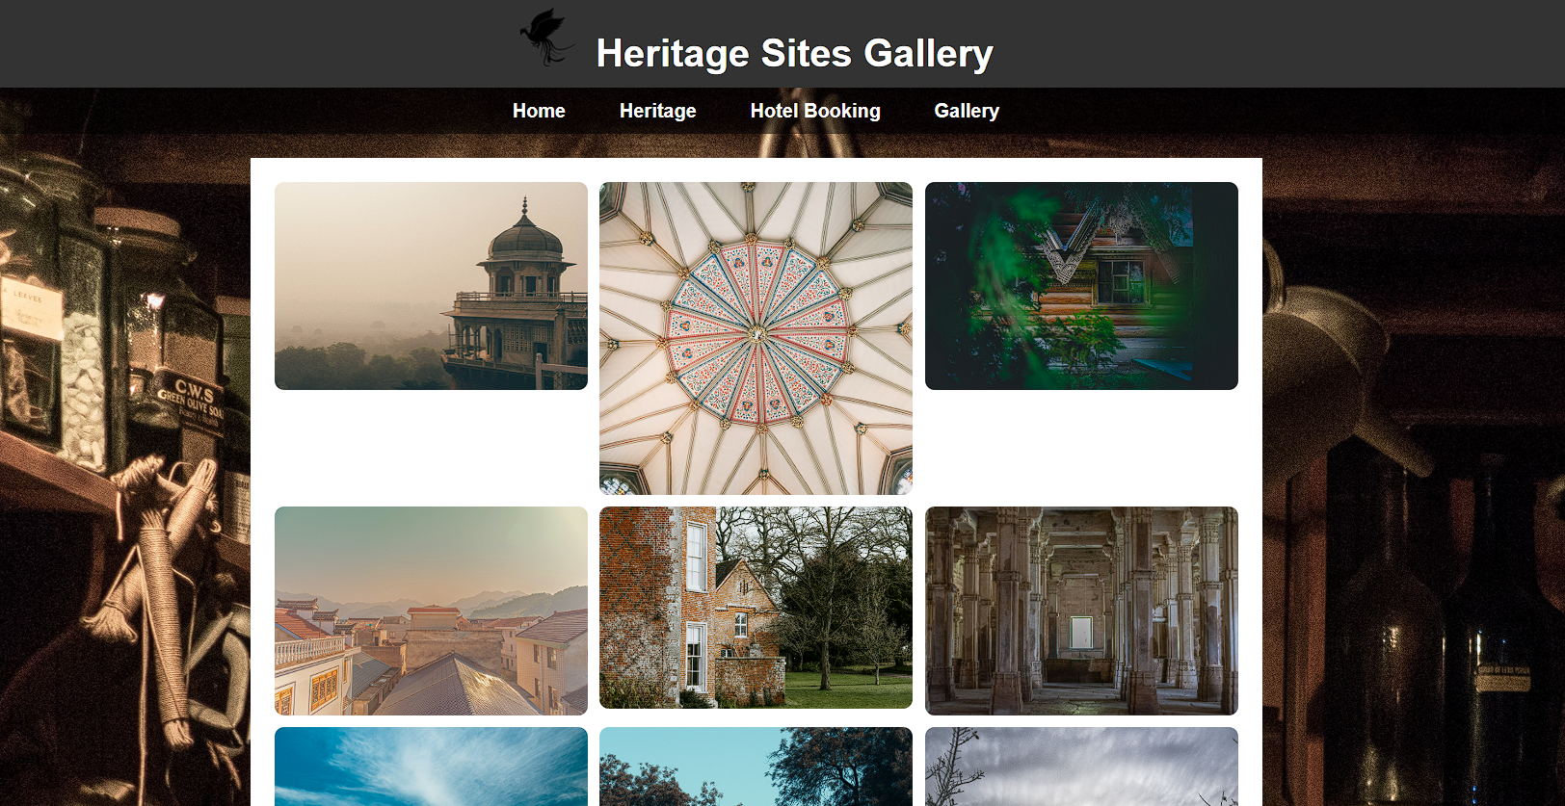

***Heritage Site 1 Page***

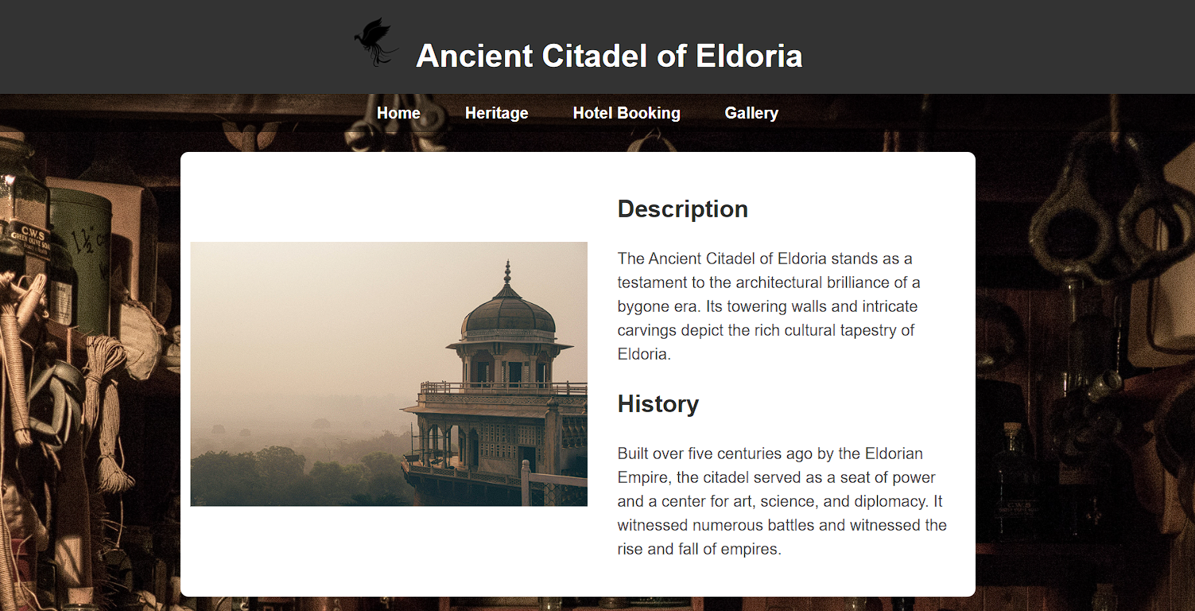

***Heritage Site 3 Page***

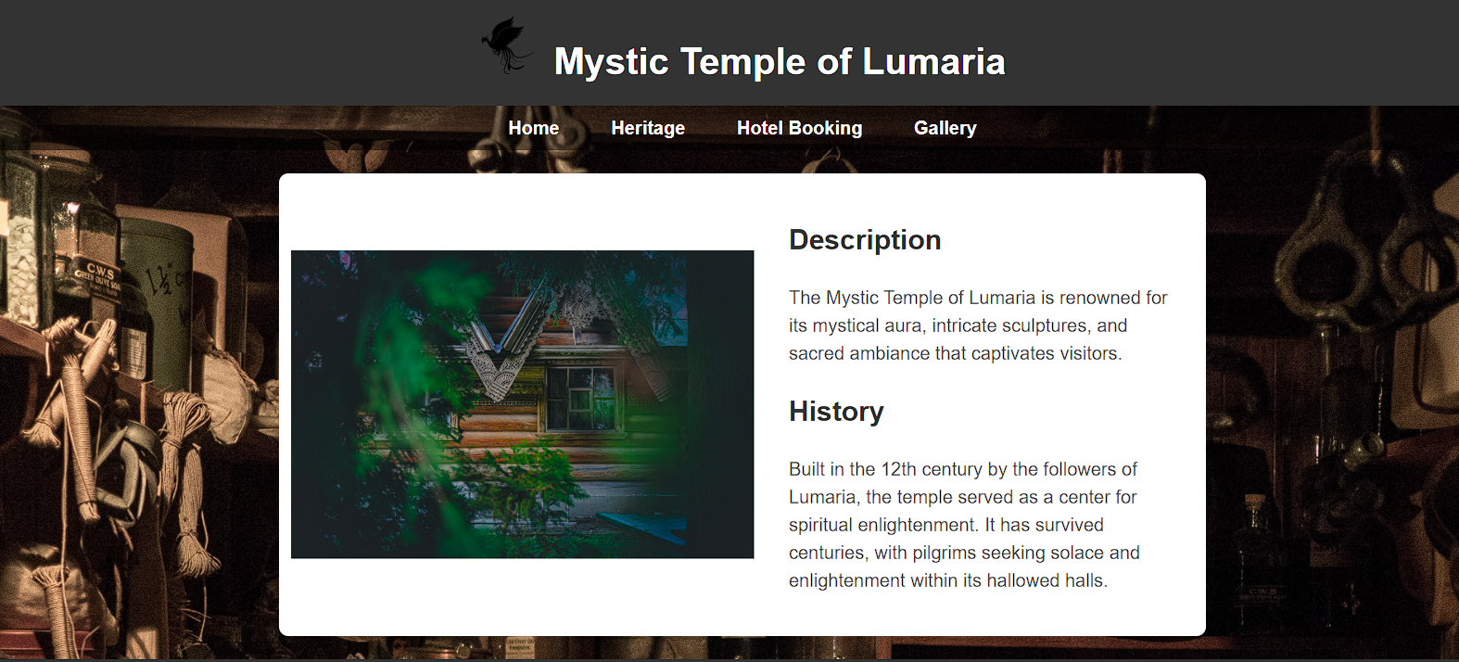

***Heritage Site 10 Page***

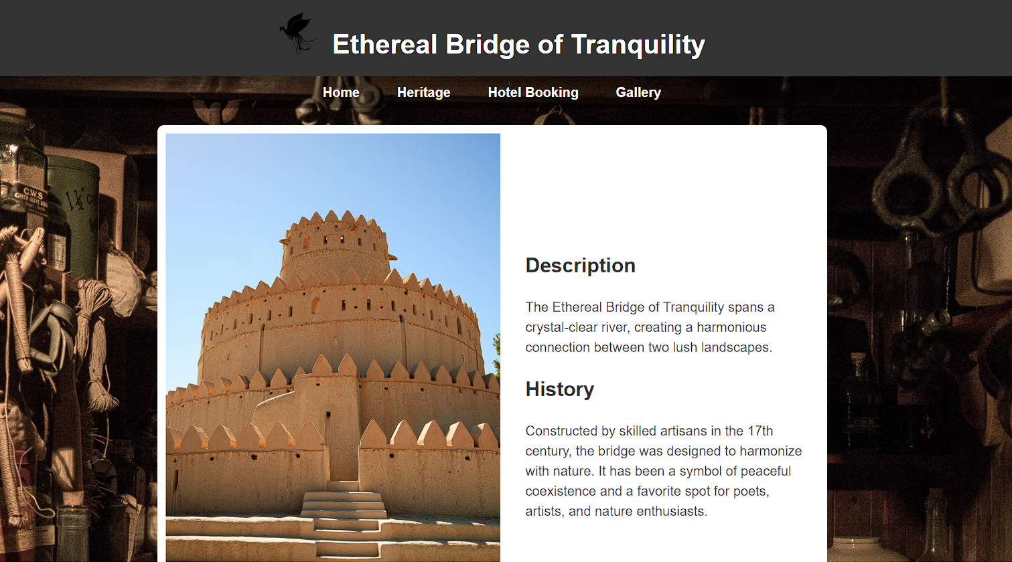

## Conclusion:

* HTML (HyperText Markup Language): Serves as the foundation for structuring content on the web.
* CSS (Cascading Style Sheets): Allows for the separation of structure (HTML) and presentation (CSS), providing a clean and organized way to style HTML elements.
* Proper HTML structure and semantic tags contribute to web accessibility
* CSS allows for the creation of animations and transitions, enhancing the user experience.